Vanier College

**Assignment 01**

**Project Planning**

Christina Kallas – 1852930

System Development (420-436-VA) section 00002

Alex Steinheuser Vilvert

I, Christina Kallas (1852930) certify that this assignment is my own work

Christina Kallas - February 4th, 2022

**Grantt and WBS with Four Human Resources:**

First Grantt Chart with four human resources


**Grantt and WBS with Eight Human Resources:**

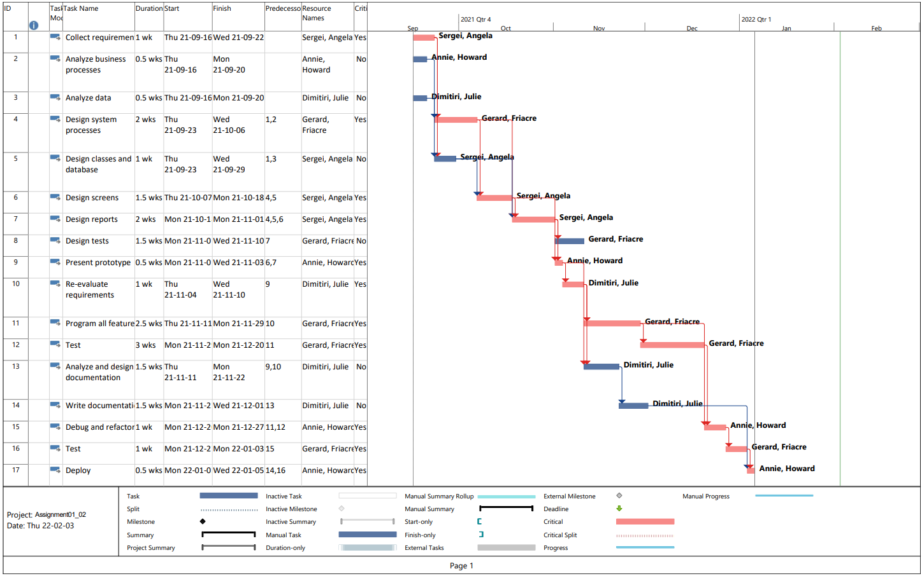

**Question 13:** In a few paragraphs, describe in detail how the addition of the extra human resources has changed the project.

The fact that each original human resource had one to match perfectly (Sergei and Angela, Annie and Howard, Dimitri and Julie, Gerard and Fiacre) meant there was no overlap within who could do which task, meaning there would always be two human resources on each of the tasks.

The obvious change after adding Angela, Howard, Julie, and Fiacre is that each task halved its duration, making the overall project take half the time it initially would have taken without these extra workers.

The way that each pair of people has a perfect overlap of skill allows for this project to double up on efficiency when working. Meanwhile, if the second set of people had different skillsets, the overlap might cause conflict in the schedule, making it where some tasks may have two or three people working on it, meanwhile others might continue to have a single person working on it, making the duration of the project between the two scenarios above.

**Question 14:** What are the end dates for the two projects? What is the duration for the two projects?

|  |  |  |
| --- | --- | --- |
|  | **Project 01 (four human resources)** | **Project 02 (eight human resources)** |
| **End date** | Wednesday, April 27th, 2022 | Wednesday, January 5th, 2022 |
| **Duration** | 45 weeks  7 ½ months | 22.5 weeks  3 ¼ months |
| **Differences** | Due to having half the workers, this project took double the amount of time as the other. | Takes half of the duration of the first project due to teamwork. |

**Question 15:** Has the critical path changed? Why or why not?  
 In a sense, the critical path has changed: it is half of its original duration, such as the rest of the project.

In reality, the critical path has not changed: it still relies on the same tasks in the same order as the original project. The reason it has not changed has been explained within question 13. The second set of people to join the project exactly match the skillset of the first set of people, making it so there is always two people who can work on a task at the same time (those with the same skillsets). If the second set of people had similar but not exact matches of skillsets, there would be times where schedules and skillsets overlap, turning the situation into one where two people may not always be on the schedule. In this scenario, some tasks may be speedy, and others slow, pending on whether there is one or two people working on these tasks. The inconsistency of durations within this scenario is what might cause the critical path to change.